Principles of Operation
Unit Handouts

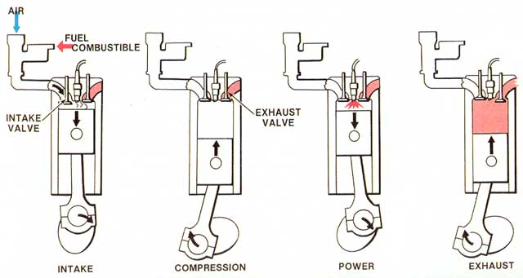

2 vs 4 Cycle Engines
Compression System
Ignition System

Name: _____________________________________ Date: ______________ Period: ________

Two-Stroke vs. Four-Stroke Engines

- Use the PowerPoint that was shared with you and the internet to help complete this worksheet: http://www.animatedengines.com/index.html and http://science.howstuffworks.com/transport/engines-equipment/two-stroke1.htm

Part One: Basic Components of Four-Stroke Engines
Instructions. Identify the parts and list the functions
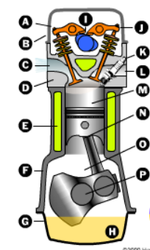

Part One: Matching
Instructions. Label the cycle
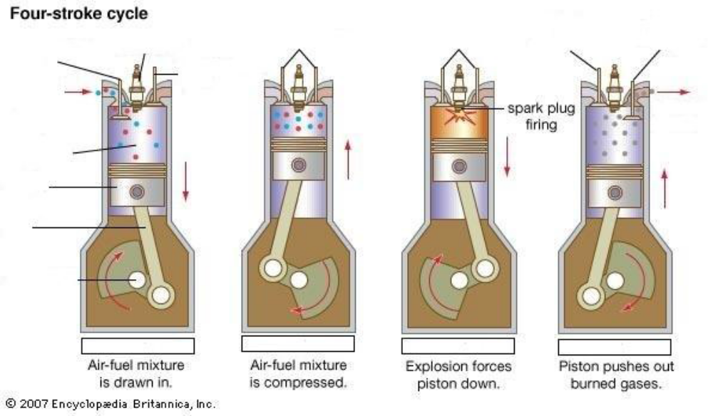

Part Three: Matching
Instructions. Match the term with the correct response. Write the letter of the term by the definition.
a. Compression c. Crankshaft e. Exhaust g. Four-stroke i. Piston
b. Connecting rod d. Diesel engine f. Gasoline engine h. Multi-cylinder j. Two-stroke

_______ 1. Works as a plunger inside the cylinder.
_______ 2. Connects the piston to the crankshaft.
_______ 3. Type of engine which has a series of four events.
_______ 4. Engines having 2 or more cylinders.
_______ 5. Engines fuel powered by grow plugs.
_______ 6. Type of engine which completes all events in two piston strokes.
_______ 7. The process of removing the spent products of combustion from the combustion chamber.
_______ 8. Engines fuel powered by a spark ignition.
_______ 9. Is a central crank-shaped shaft which all connecting rods are fastened.
_______ 10. Process of compressing the fuel and air mixture in the combustion chamber.

Part Four: 2-Cycle Engine
Instructions. Identify the parts of the 2-Stroke Engine.
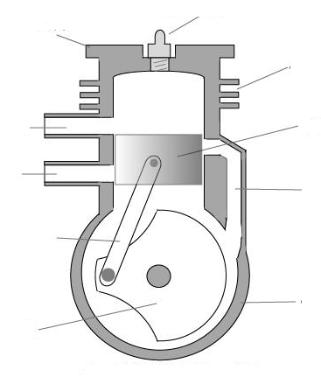
Part Three: Short Answer
Instructions. Provide information to answer the following questions.
- Explain the four-stroke cycle process:

2. Explain the two-stroke cycle process:

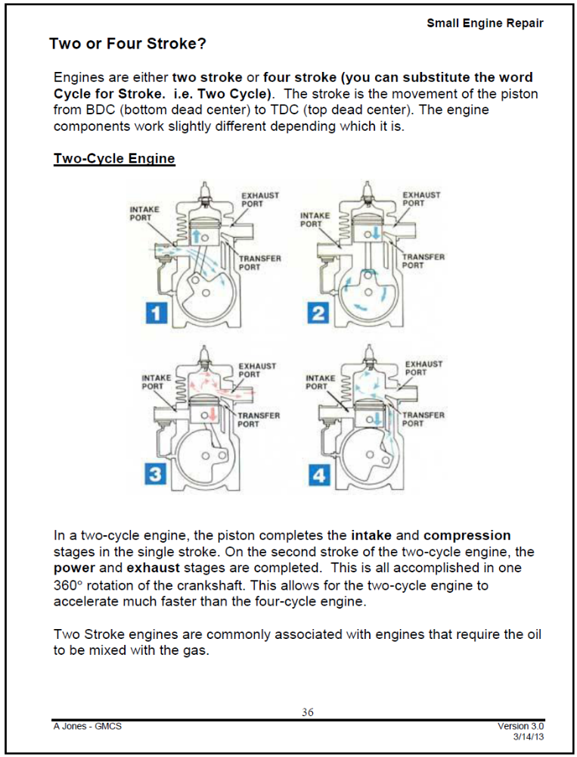
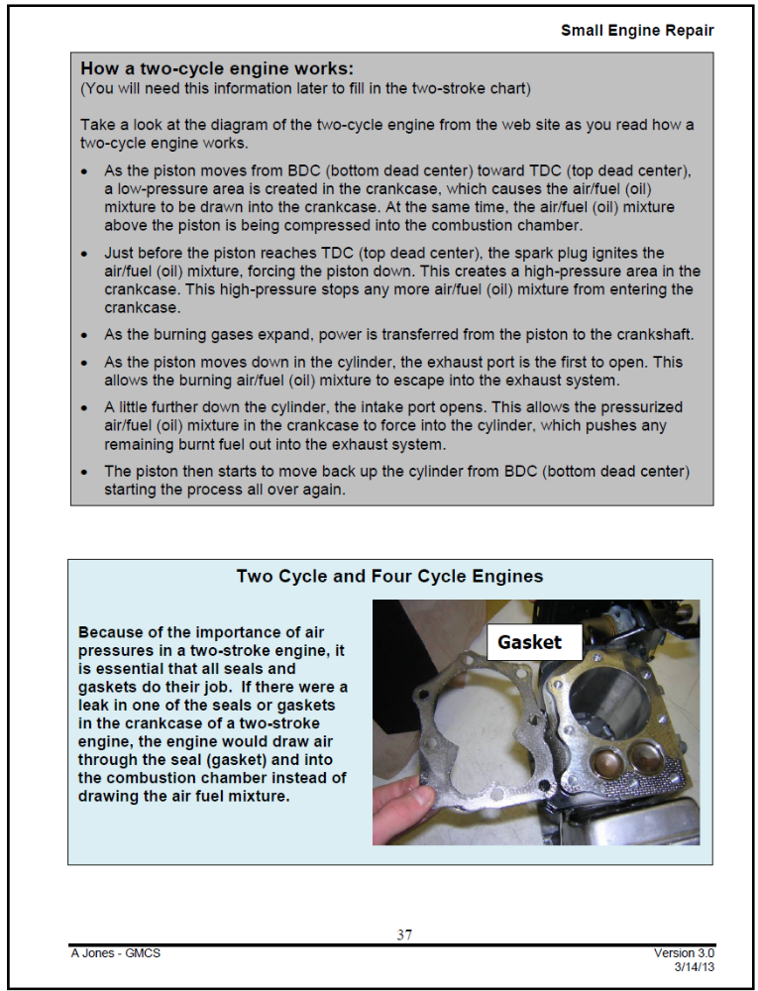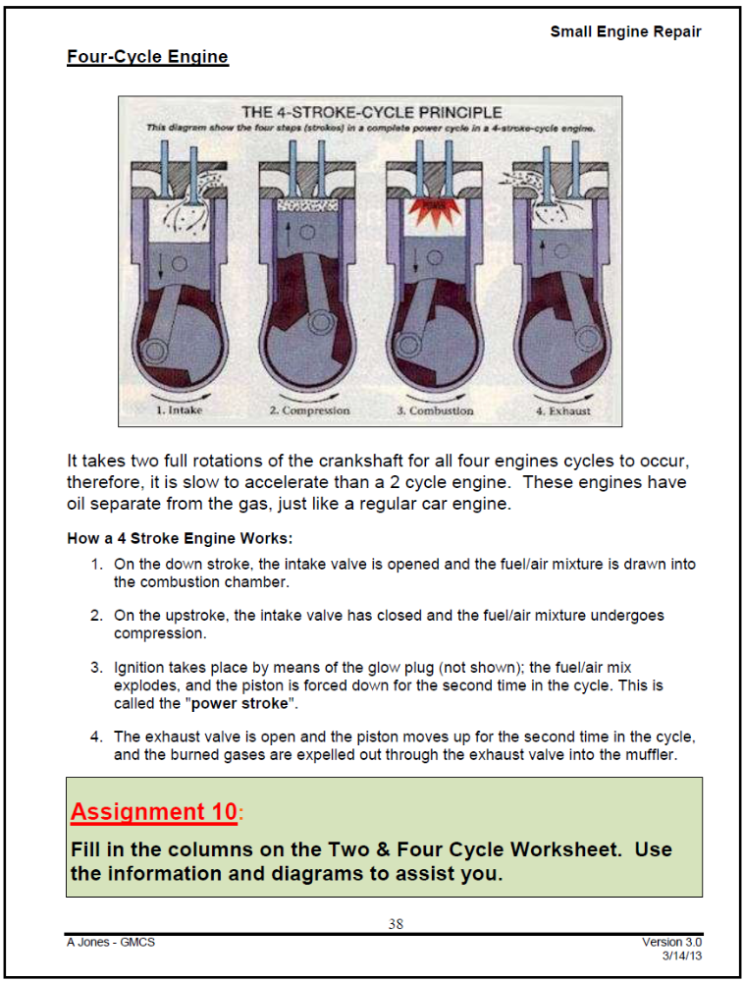

Name: _________________________________________________ Date: __________________ Period: ____

Comparing 2 and 4 Stroke Engines

Use the class notes, textbooks, and Internet to complete the chart. Most answers will be terms that compare such as Heavier and Lighter or Hotter and Cooler.

 | 4-Stroke | 2-Stroke
# of major moving parts
(give specific #)
Power Strokes
Running Temperature
(Hotter/Cooler)
Overall Size
(Smaller/Larger)
Weight
(Heavier/Lighter)
Bore size equal Hp
(Larger/Smaller)
Fuel and Oil
(Describe mixture)
Fuel Consumption – gallons per hour (More/Fewer)
Oil Consumption
(Describe)
Sound
(Louder/Quieter)
Operation
(Smoother/Erratic)
Acceleration
(Quick/Slow)
General Maintenance
(Greater/Less)
Initial Cost
(Greater/Less)
Versatility of Operation – Handles slopes (Limited/Unaffected)
Efficiency – hp/wt. ratio
(Greater/Less)
Pull Starting - # of crankshaft revolutions required
Flywheel Requirements
(Lighter/Heavier)

Pros and Cons
 | Pros | Cons
4 - Stroke
2 - Stroke

Stroke Cycles – Describe when, where, and how each event takes place
 | 4-Stroke | 2-Stroke
Intake
Compression
Power
Exhaust
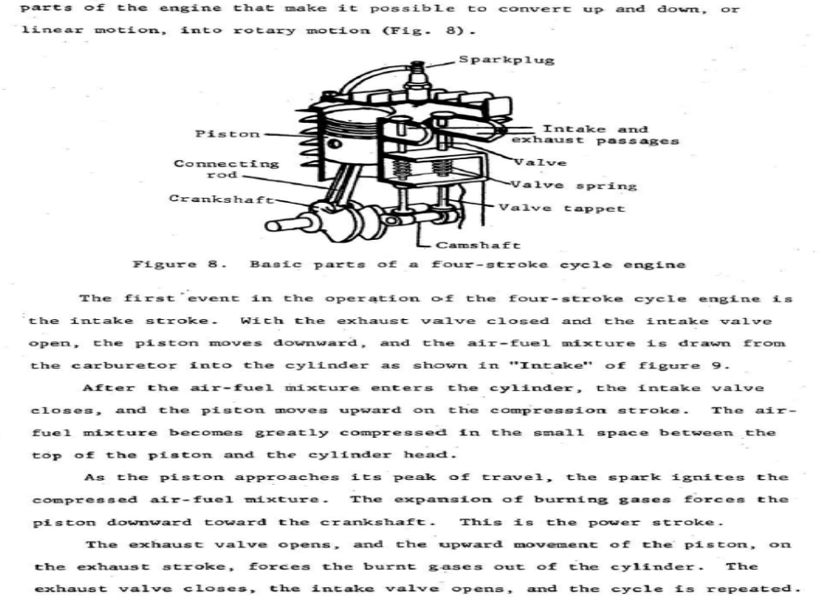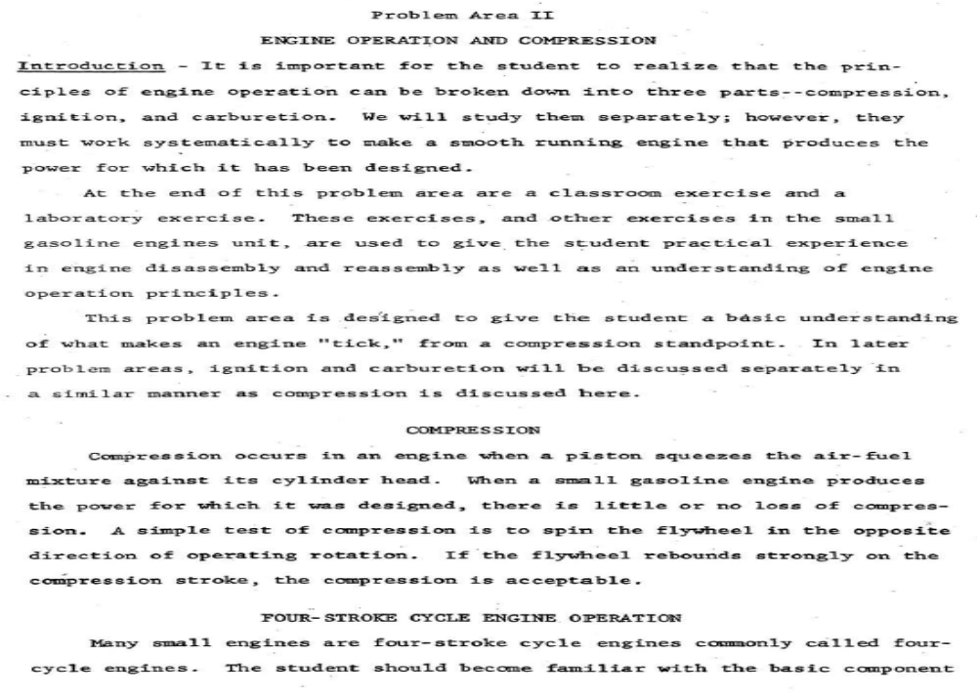
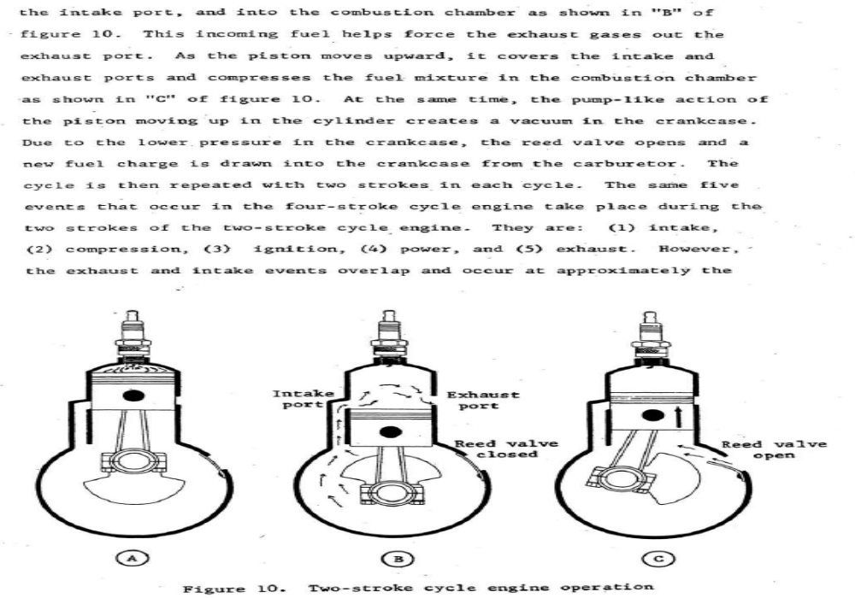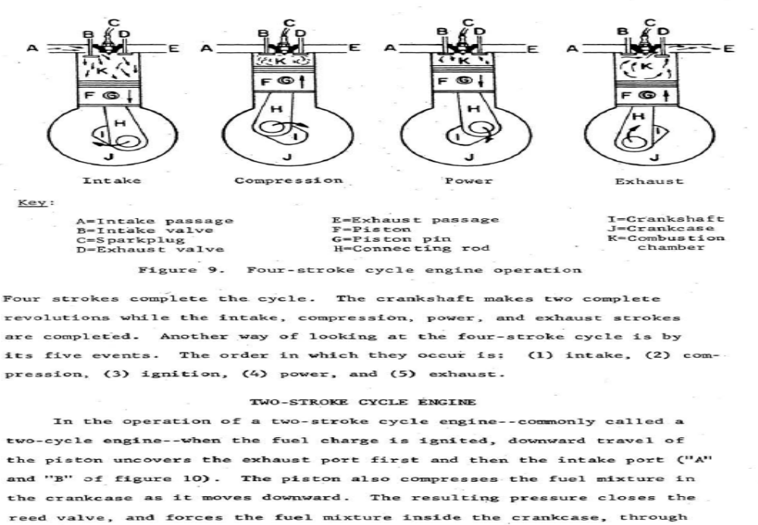
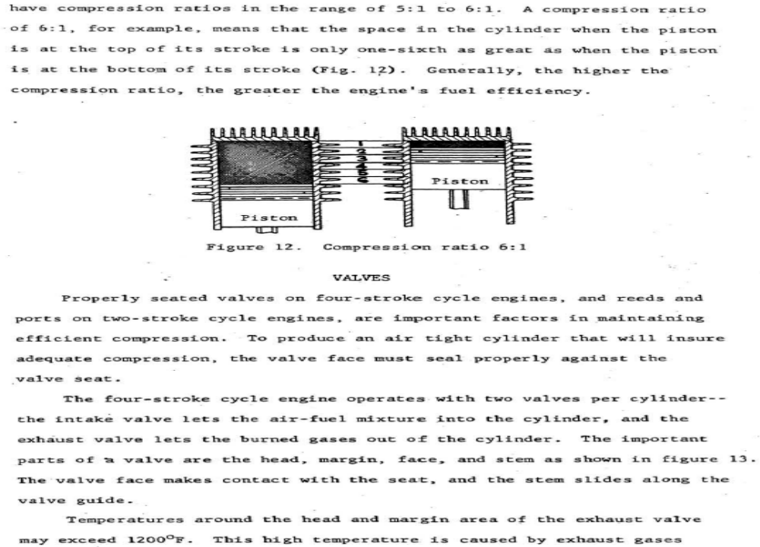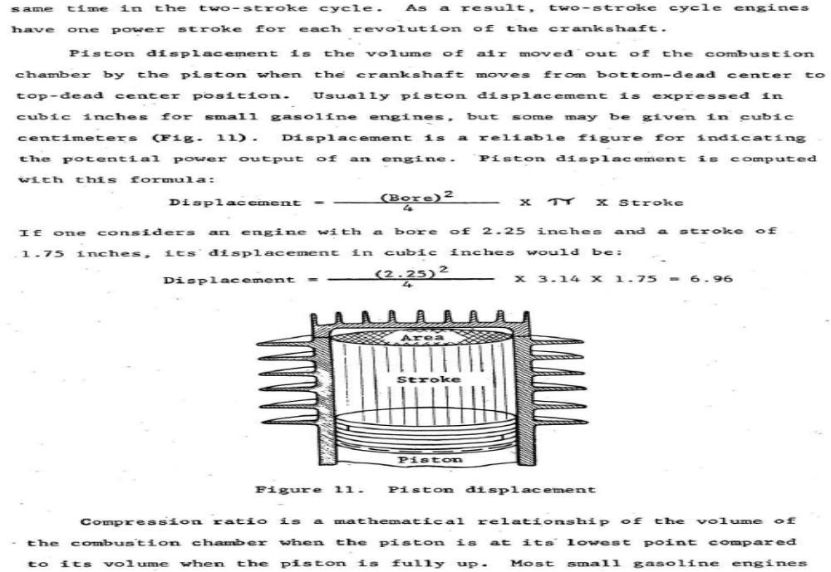
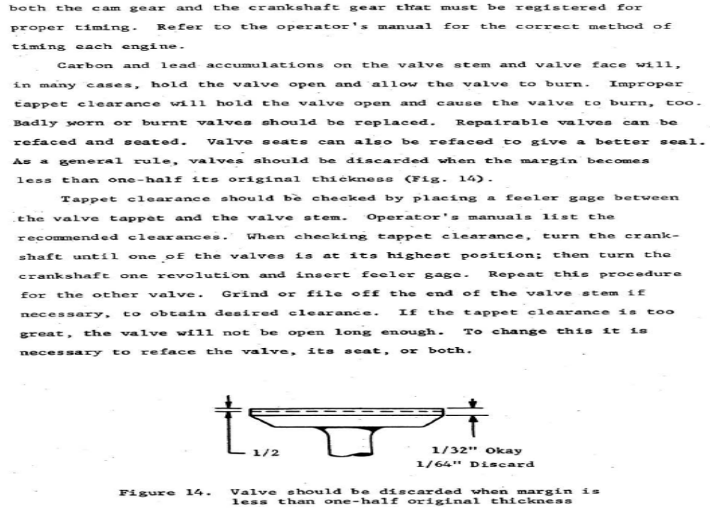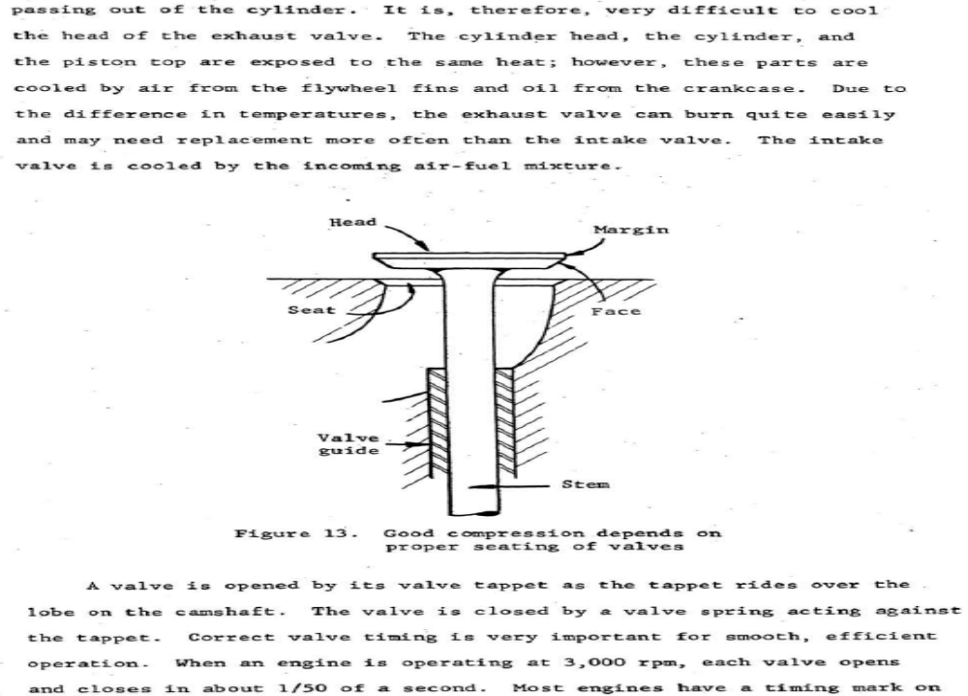
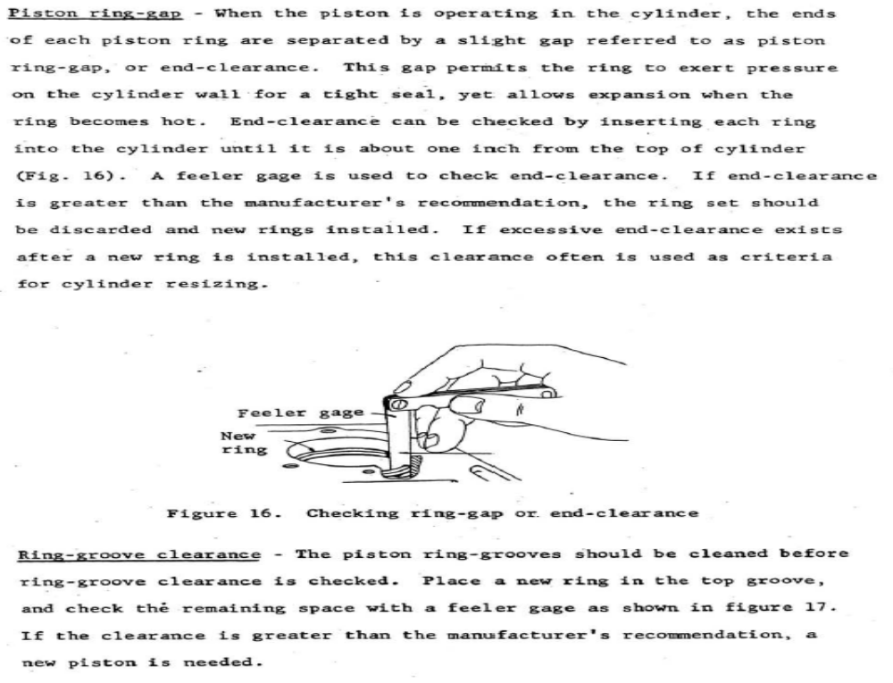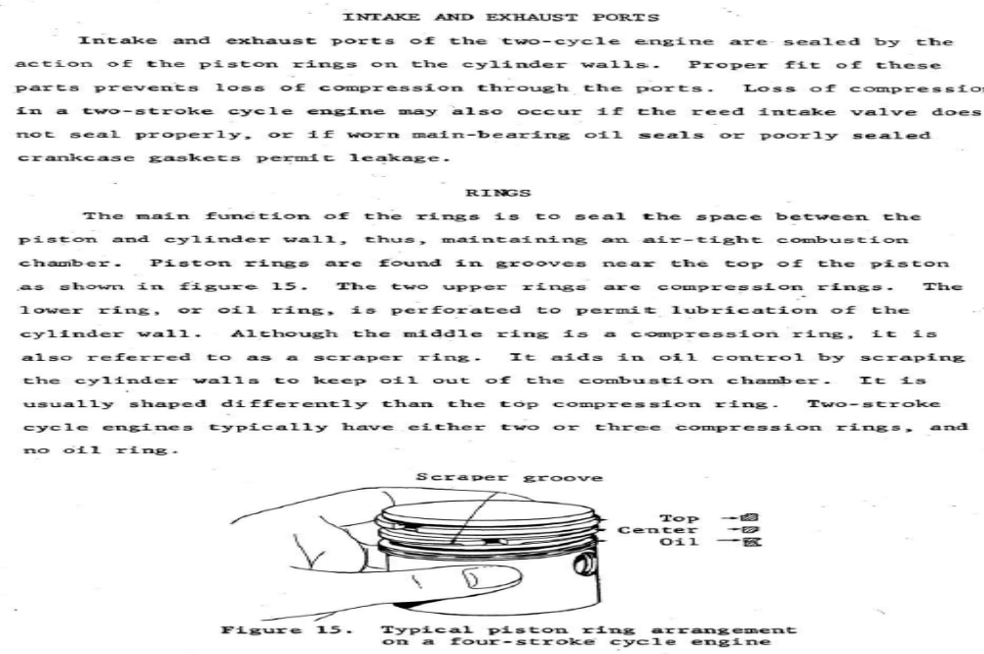

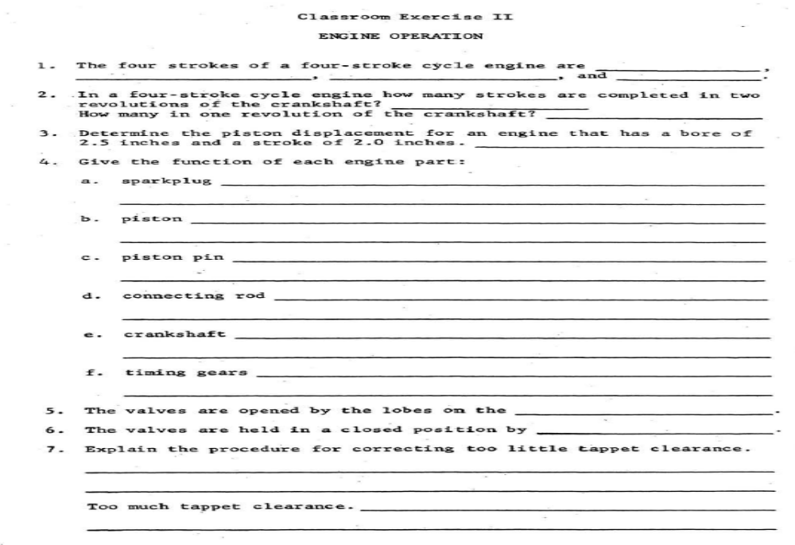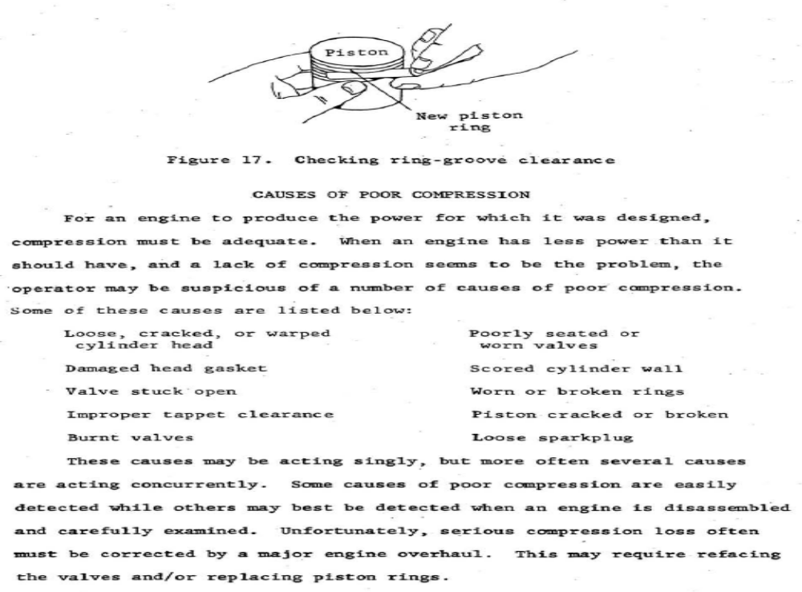
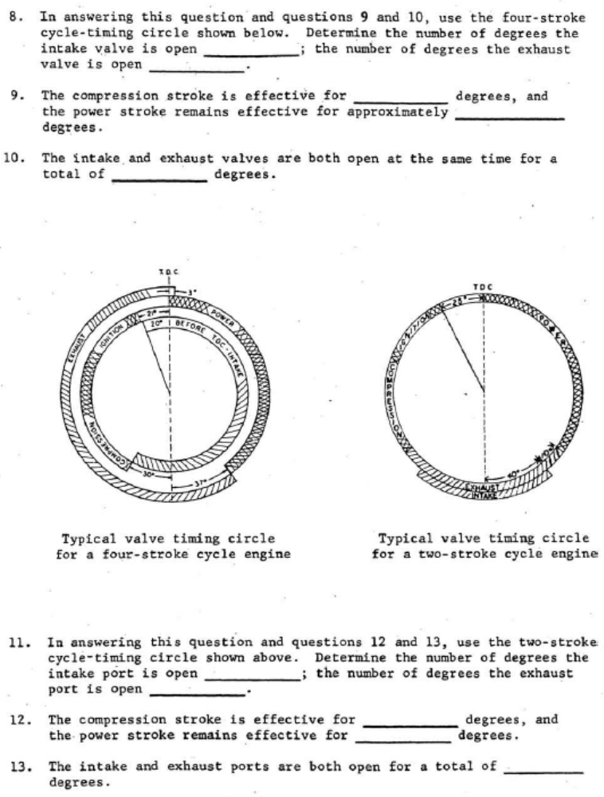
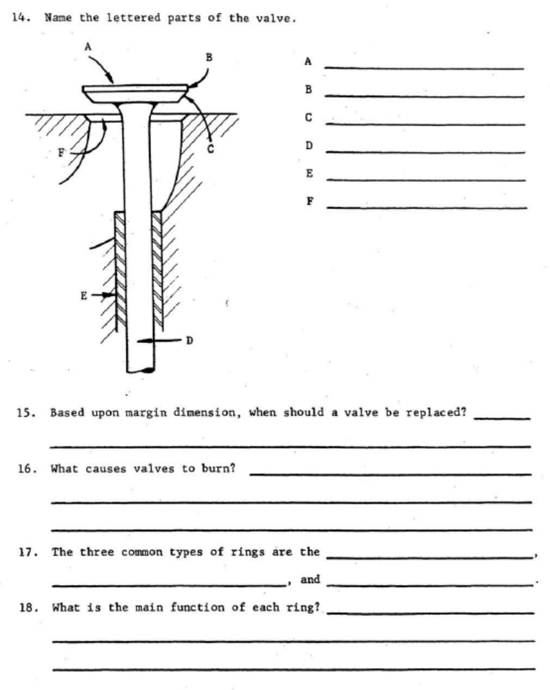

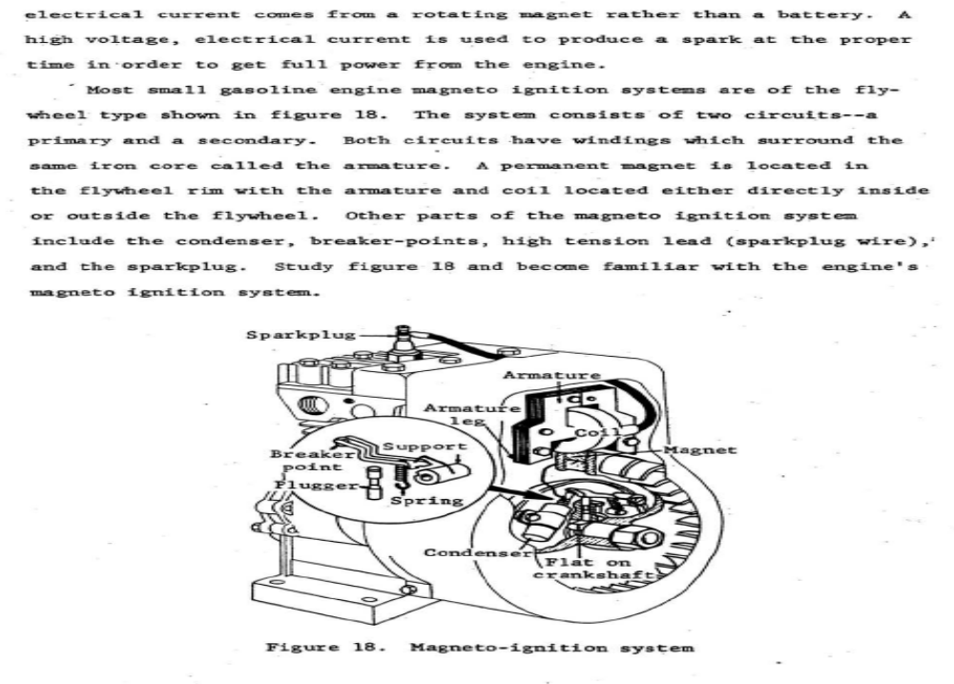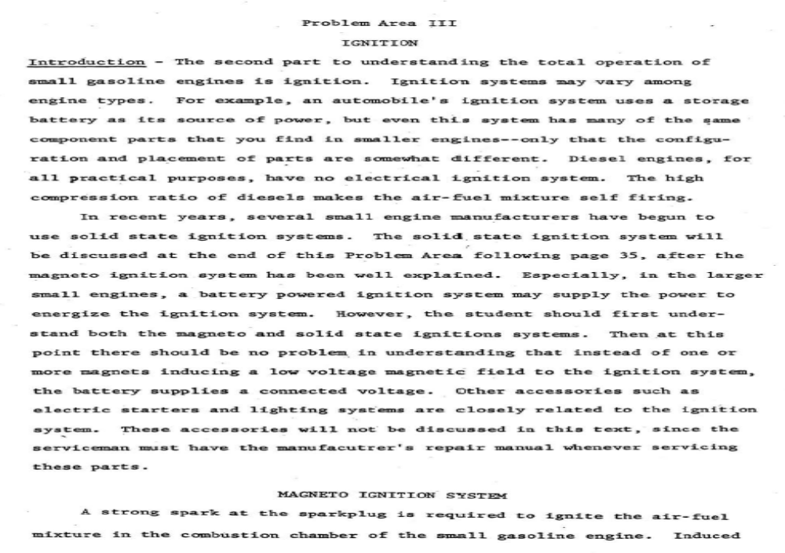
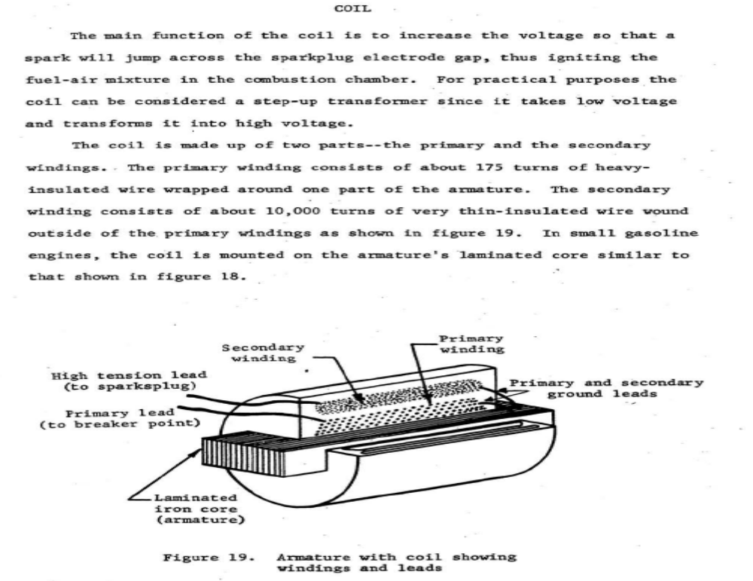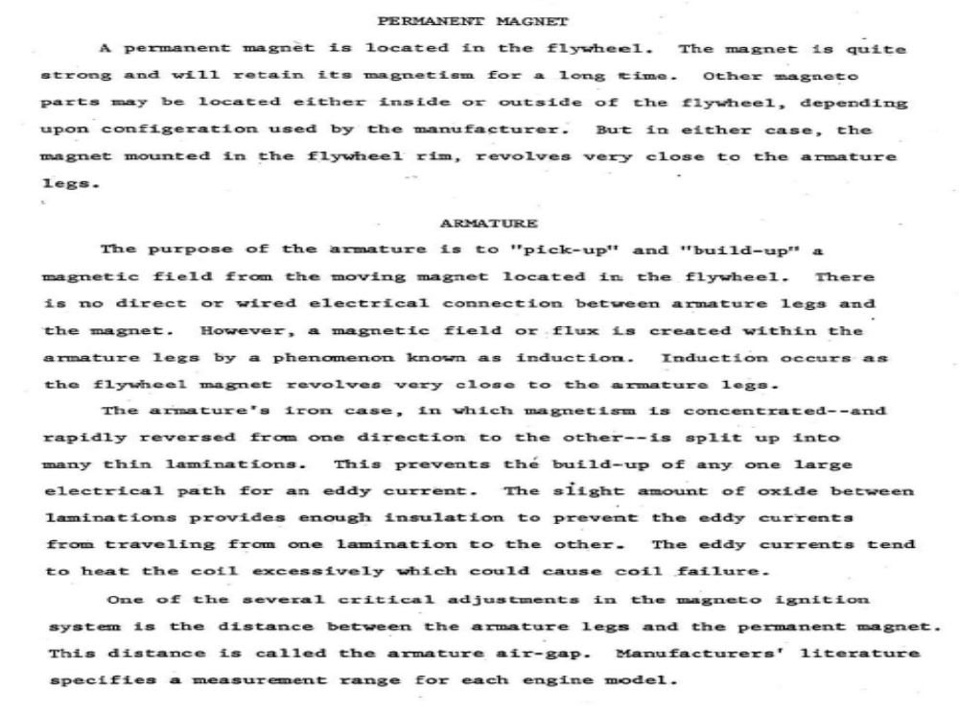
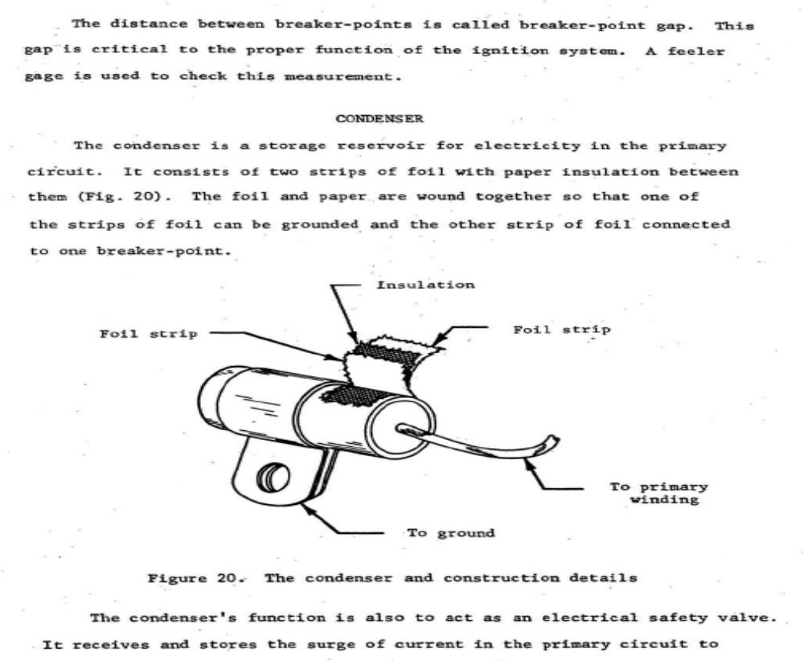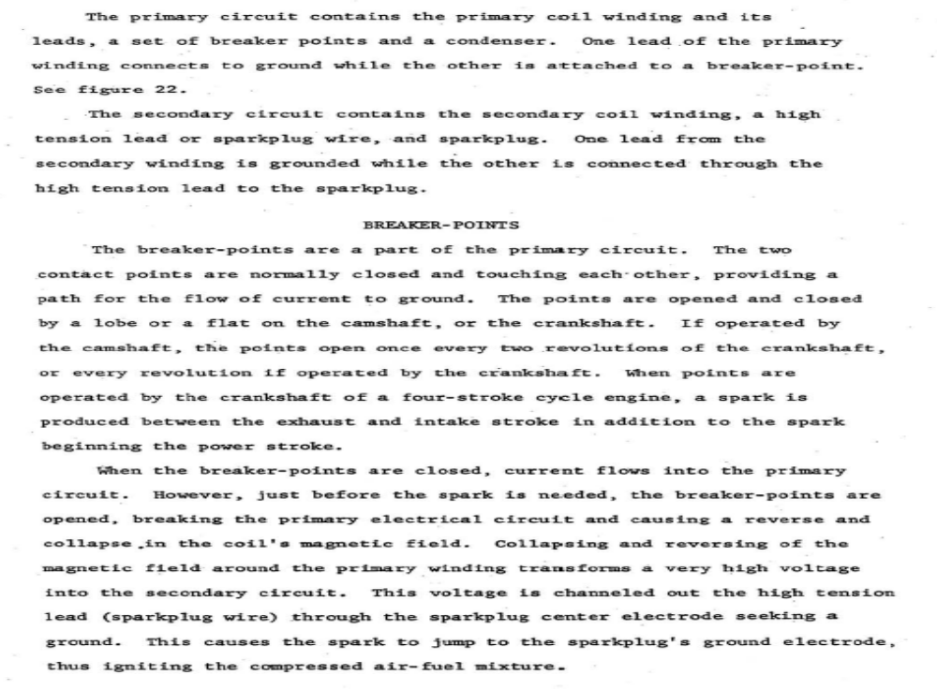
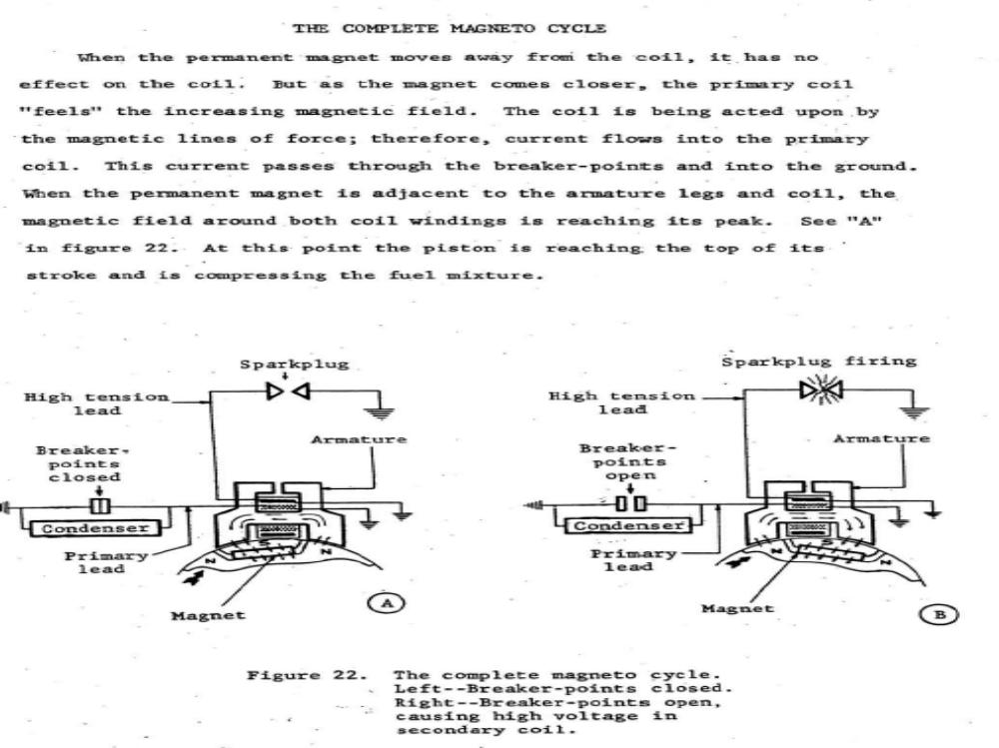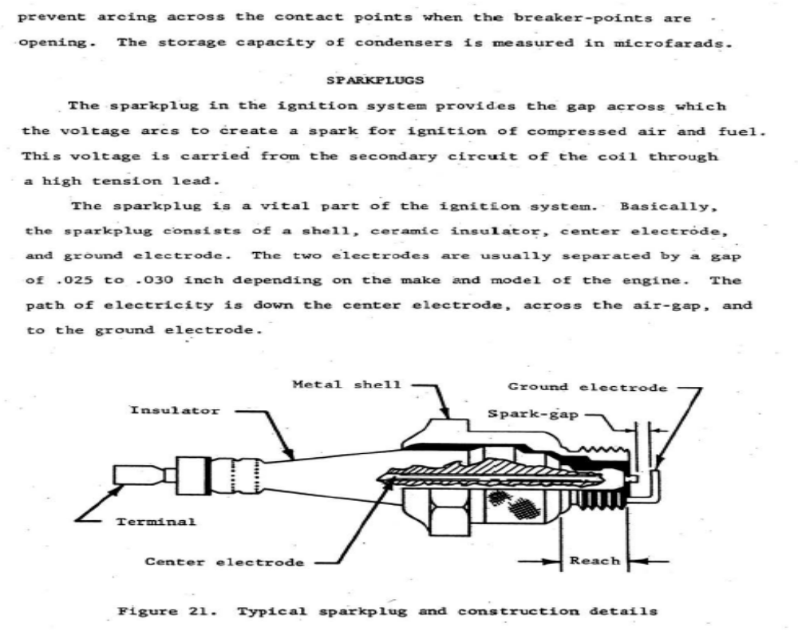
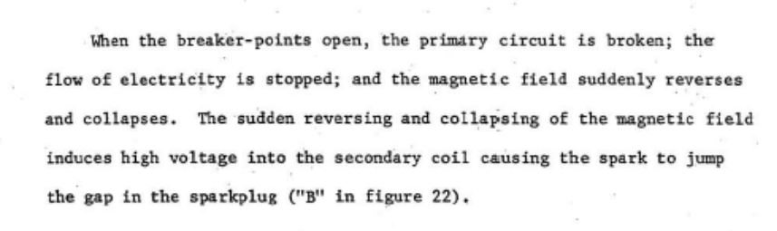

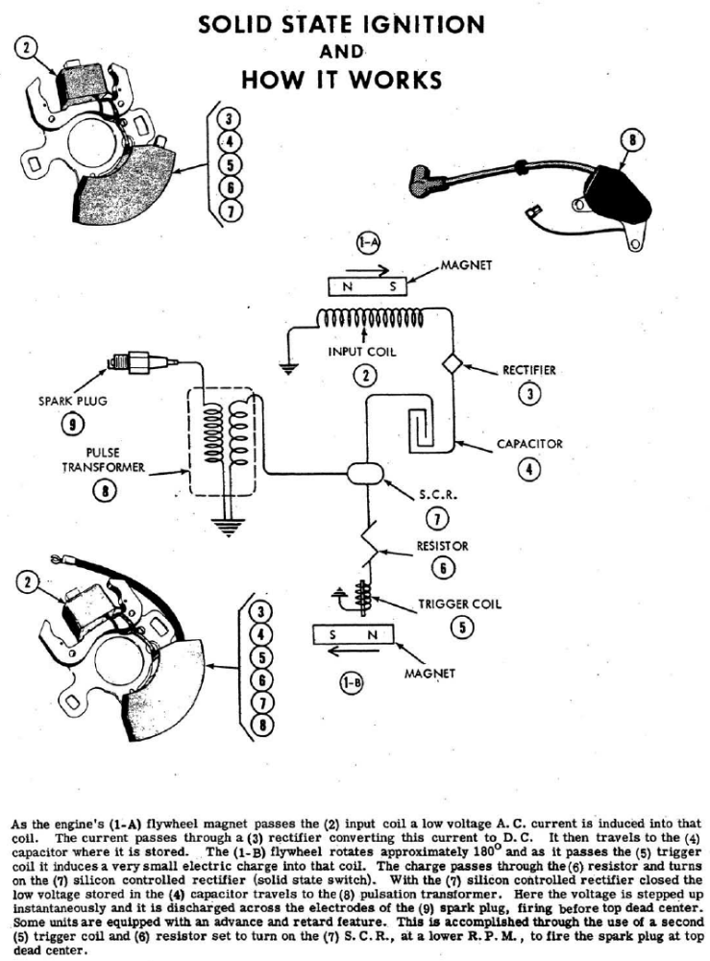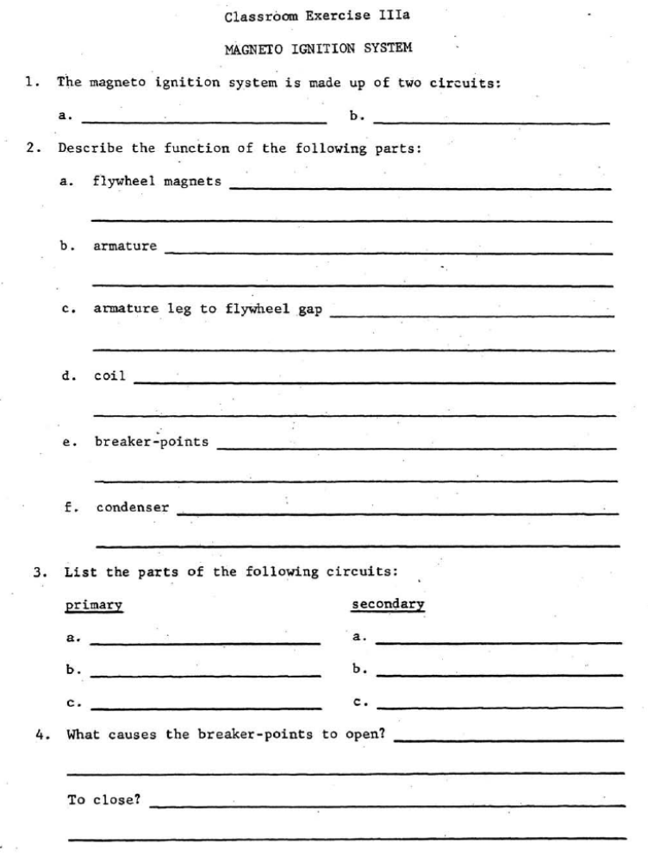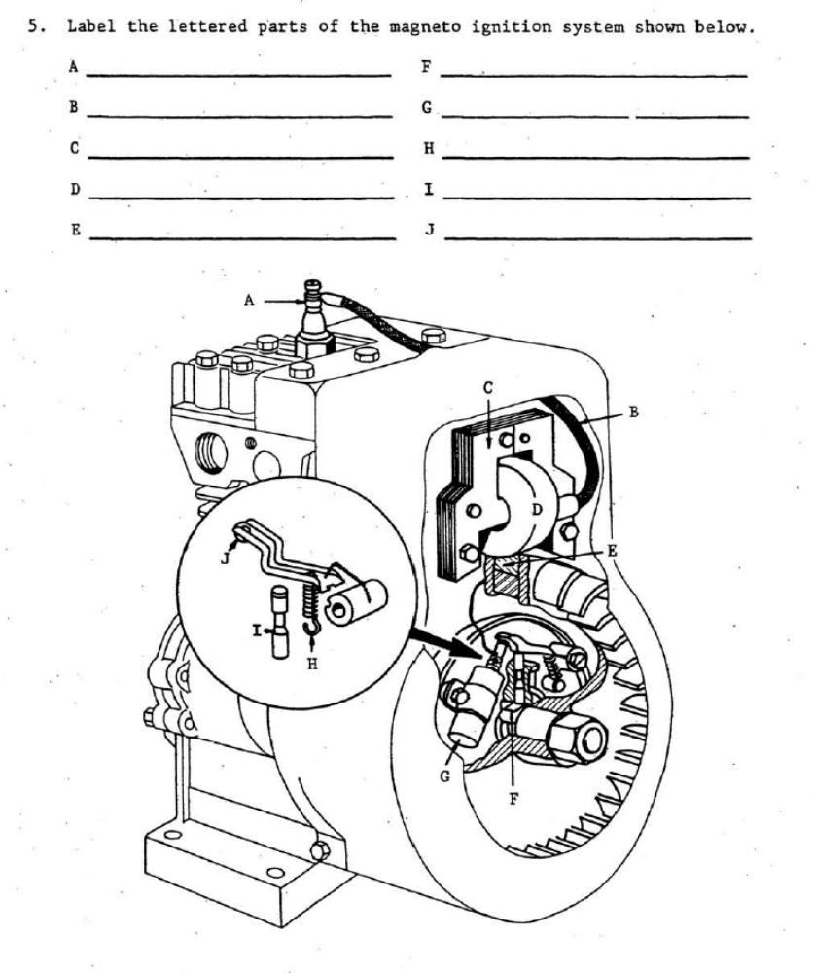
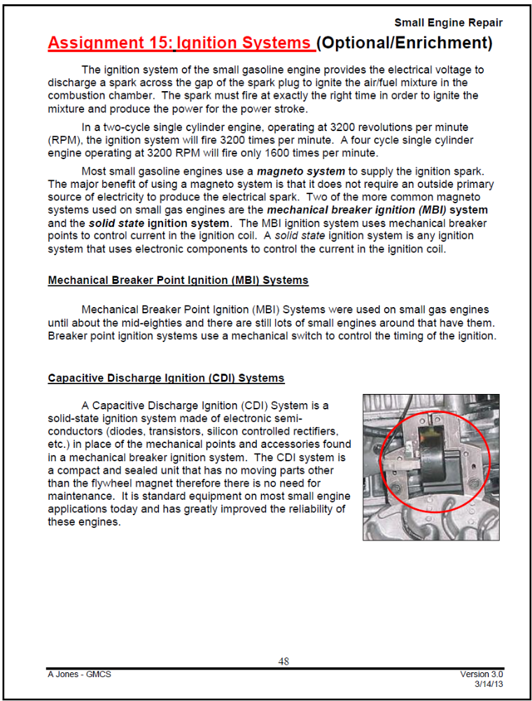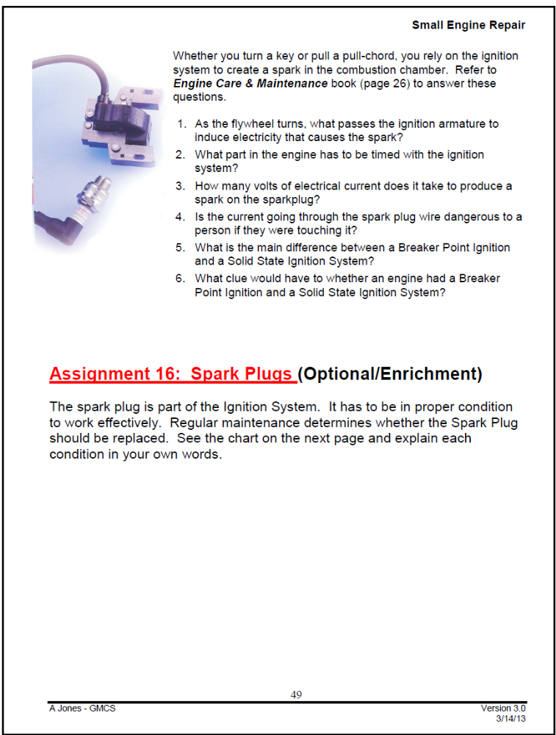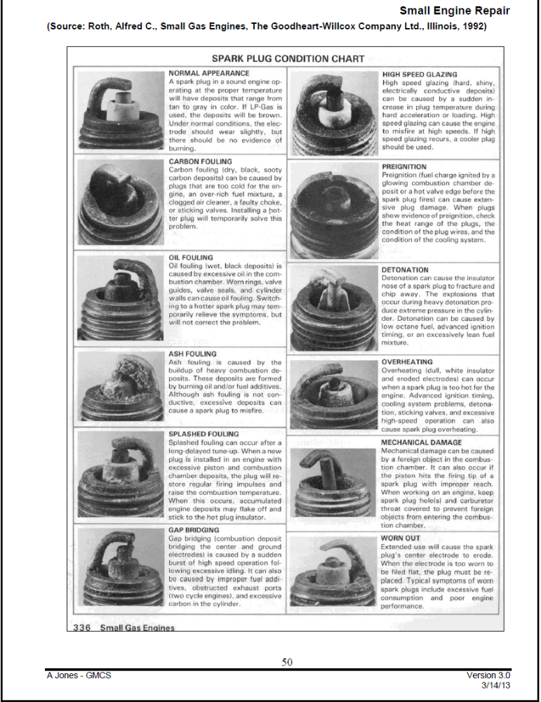

Name:___________________________________________________ Date: ______________ Period: _______

Ignition System

Use the reading, textbook, and Internet to answer the following questions:

- As the flywheel turns, what passes the ignition armature to induce electricity that causes the spark?
- What part in the engine has to be timed with the ignition system?
- How many volts of electrical current does it take to produce a spark on the sparkplug?
- Is the current going through the spark plug wire dangerous to a person if they were touching it?
- What is the main difference between a Breaker Point Ignition and a Solid State Ignition System?
- What clue would have to whether an engine had a Breaker Point Ignition and a Solid State Ignition System?

Describe the Spark Plug Conditions in your own words:
- Normal –
- High Speed Glazing –
- Carbon Fouling –
- Preignition –
- Oil Fouling –
- Detonation –
- Ash Fouling –
- Overheating –
- Splashed Fouling –
- Mechanical Damage –
- Gap Bridging –
- Worn Out –

