Engine Components

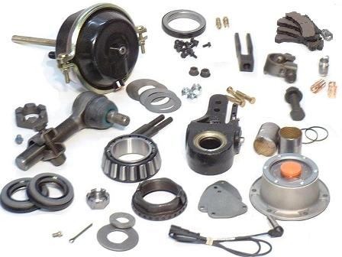

Unit Handouts

Name: ____________________________________ Date: __________________ Period: _________

Engine Systems Vocabulary

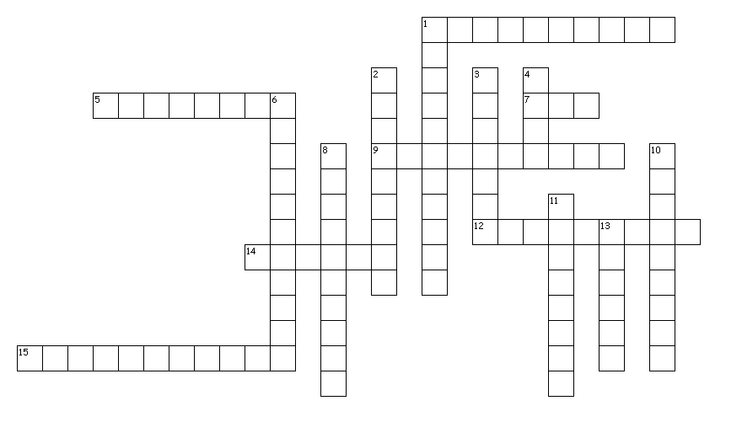
Across
1. The flow of electricity though a conducting body
5. A heavy wheel in which energy is absorbed and stored by means of momentum
7. A measurement of the resistance to the flow of an electrical current though a conductor.
9. A transfer of heat by circulating heated air
12. A device inserted into the combustion chamber of an engine that contains an electrode for conducting current
14. A soft, pliable material used between engine parts to seal and prevent leakage
15. The reduction in volume or the squeezing of a gas

Down
1. Extended pieces of metal that help dissipate heat
2. The resistance to flow
3. Unit of measurement for flow of electric current
4. A unit of electrical force that will causes a current of one ampere to flow through a resistance of one ohm
6. Process used to reduce friction
8. The main shaft of an engine that changes the reciprocating motion of the pistons into rotary motion
10. An electrical conductor
11. Resistance to motion created when one surface rubs against another
13. A cylindrical parts that is closed at one end and connected to the crankshaft y the connecting rod

Engine Systems Word Search

T I K C B G X Q R A D Y Y F W R F O V T S Y J H L
L R L O C R U Z U H L V C E L U J V X N O T N M W
Z H B N P S V L V O E J M O Z Y Z D I X O I Y K B
T W N D F A H S P I T P P R M A W F J I P S B X T
N B Y U T F A H S K N A R C S B G H S P B O Q Q A
K Z U C L A S Y X D R W E U V N U K E X O C Y T B
V E G T E R E P M A G A J H I M B S W E C S P T P
M K R I W V B T L E U F P L W B E I T O L I H J U
A W B O S P F K U S H R O S G Q B Y N I W V S W I
K A E N L A F H P V P O A U M Y G V H P O E M Z Y
U R N M H F P H S Z C D Q C U A E S T G B N H G P
T W C S L U B R I C A T I O N C L P M U H I O B U
R G M P J S G P I S T O N T T S Y L Q S U G N O H
L A T N F L U P W G E D E I G J H U M G E N T E U
C T L Z R B O Q S D G K O R L D Q X R S C E H S Q
S R C D I K V V H A S N D Q V L H I L T O N H C W
W R X S C M R Z S A R E W L D L K E I D W I O W W
E T H P T E I O G Z T L Y G O V A B M R L A H K J
O C Y W I A L C Y L I N D E R O C C I F U Z G Q Y
L F M G O I L W I S K K U K P L F A J W M W V N A
D E N H N H W T Q B U Y G X L T W R R S A Z Q H H
K V S E R A O R Z N J N B S P S K R J Q U N A F L
J G H E T C B K J K V P S X W Z L R F F X S V K Q
A V X E I Z Q D S P B J X S W T M X R P K Z E W R
K P R V B D K J L T Z Y J L Q X U N U N A R A G W

AIR
AMPERE
CAMSHAFT
COMBUSTION
CONDUCTION
CONVECTION
COOLINGFINS
CRANKSHAFT
CYLINDER
DIESEL
ENGINE
FLYWHEEL
FRICTION
FUEL
GASKET
GASOLINE
HEAT
LUBRICATION
OHMS
PISTON
SMALL
SPARKPLUG
VISCOSITY
VOLTS
WATER

Small Engine Parts Notes
Engine Parts

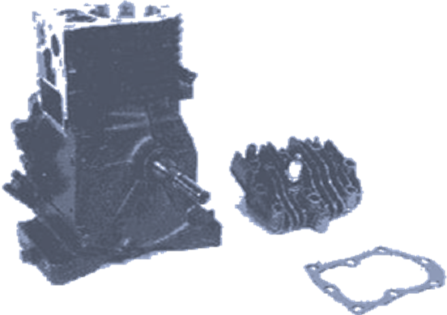

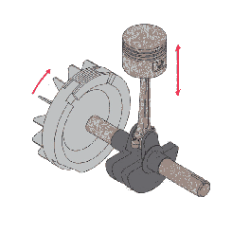

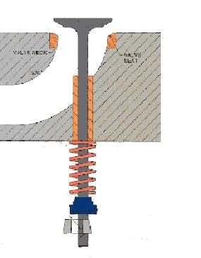

Name: _____________________________ Date:________________ Period: ________
Engine Parts ID
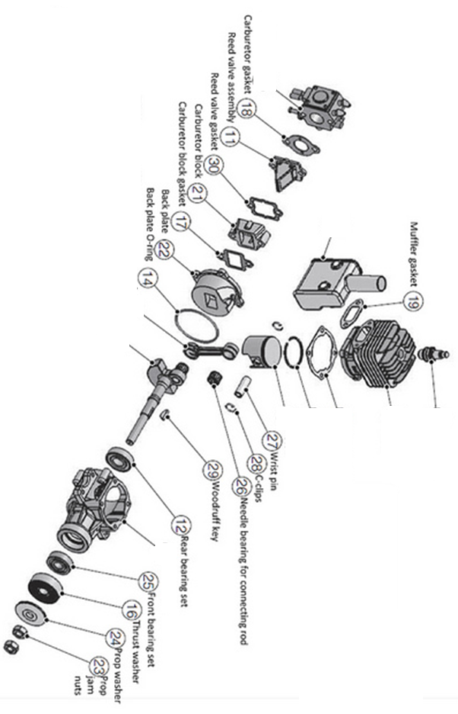
Label the Parts on the Engines
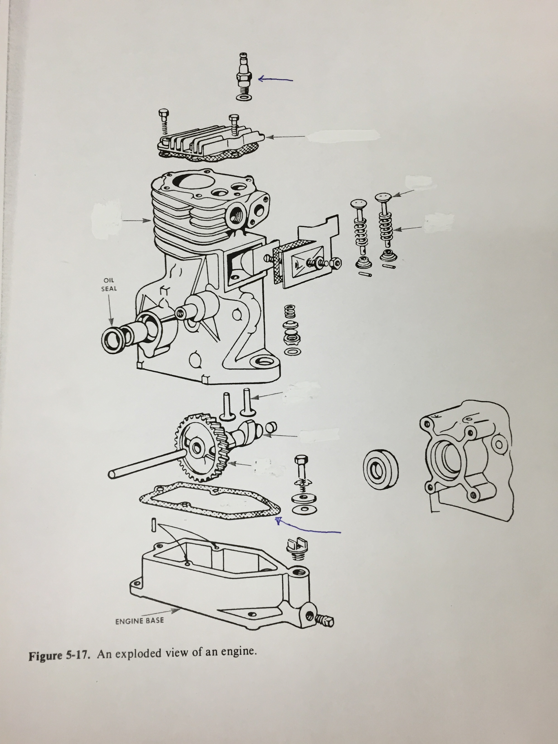
Using your own words, Define and Illustrate Each Part
Part | Definition | Illustration
Camshaft
Compression Ring
Connecting Rod
Crankcase
Crankshaft
Cylinder
Cylinder Head
Engine
Part | Definition | Illustration
Exhaust Valve
Flywheel
Intake Valve
Piston
Piston Pin
Valve
Valve Guide
Valve Spring
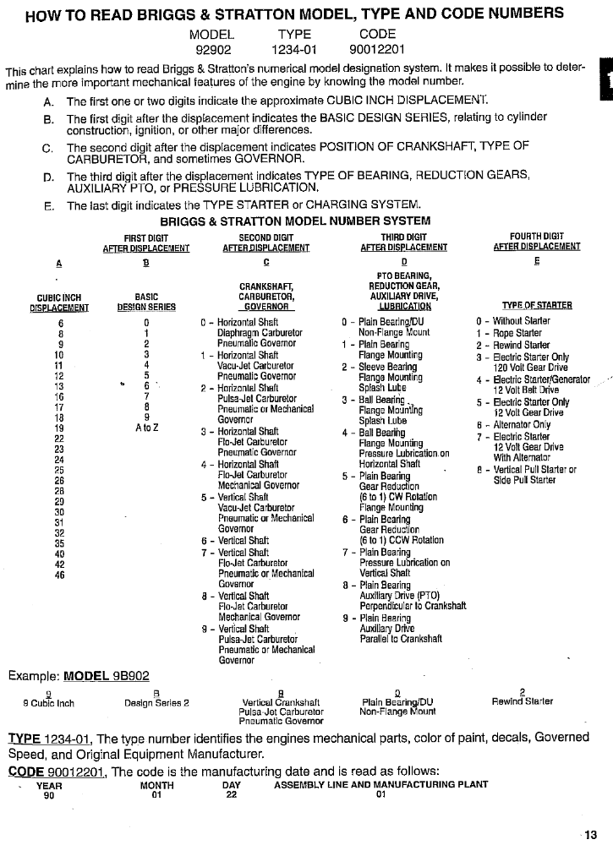
Model # 81297 7360 86070615
Column
# = ______ A. Cubic Inch Displacement = ___________________
# = ______ B. Basic Design Series = ___________________
# = ______ C. Crankshaft Type = ___________________
# = ______ Carburetor = ___________________
# = ______ Governor = ___________________
# = ______ D. Bearings (PTO) = ___________________
# = ______ Reduction Gears (if applicable) ___________________
# = ______ Auxiliary PTO Drives (if applicable) = ___________________
# = ______ Lubrication (if applicable) = ___________________
# = ______ E. Type of Starter = ___________________
# = ______ Charging System (if applicable) = ___________________
Manufacture Date: Month_____________________ Day ________________ Year___________
Manufacture Plant Number: ___________

Name ________________________________________________ Date _________________
Briggs & Stratton Engine Identification
Using the Numbering Identification System write down the correct answer to the Questions
1. Model # 92402 3492 031127
Column
# = ______ A. Cubic Inch Displacement = ___________________
# = ______ B. Basic Design Series = ___________________
# = ______ C. Crankshaft Type = ___________________
# = ______ Carburetor = ___________________
# = ______ Governor = ___________________
# = ______ D. Bearings (PTO) = ___________________
# = ______ Reduction Gears (if applicable) ___________________
# = ______ Auxiliary PTO Drives (if applicable) = ___________________
# = ______ Lubrication (if applicable) = ___________________
# = ______ E. Type of Starter = ___________________
# = ______ Charging System (if applicable) = ___________________
Manufacture Date: Month_____________________ Day ________________ Year___________

2. Model # 92908 7298 091229
Column
# = ______ A. Cubic Inch Displacement = ___________________
# = ______ B. Basic Design Series = ___________________
# = ______ C. Crankshaft Type = ___________________
# = ______ Carburetor = ___________________
# = ______ Governor = ___________________
2. Model # 92908 7298 091229
Column
# = ______ D. Bearings (PTO) = ___________________
# = ______ Reduction Gears (if applicable) ___________________
# = ______ Auxiliary PTO Drives (if applicable) = ___________________
# = ______ Lubrication (if applicable) = ___________________
# = ______ E. Type of Starter = ___________________
# = ______ Charging System (if applicable) = ___________________
Manufacture Date: Month_____________________ Day ________________ Year___________

3. Model # 110902 2110 74013125
Column
# = ______ A. Cubic Inch Displacement = ___________________
# = ______ B. Basic Design Series = ___________________
# = ______ C. Crankshaft Type = ___________________
# = ______ Carburetor = ___________________
# = ______ Governor = ___________________
# = ______ D. Bearings (PTO) = ___________________
# = ______ Reduction Gears (if applicable) ___________________
# = ______ Auxiliary PTO Drives (if applicable) = ___________________
# = ______ Lubrication (if applicable) = ___________________
# = ______ E. Type of Starter = ___________________
# = ______ Charging System (if applicable) = ___________________
Manufacture Date: Month_____________________ Day ________________ Year___________
Manufacture Plant Number: ___________

