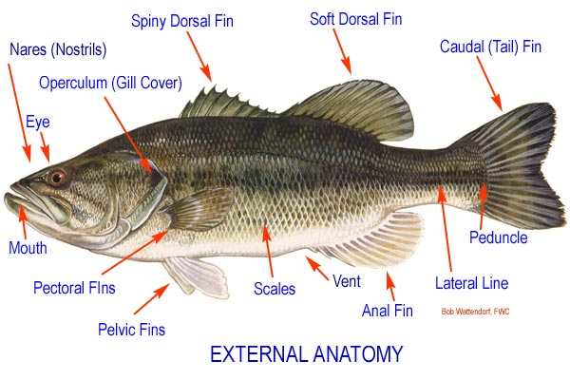
The fins are used for movement, stability, nest-building, spawning, and as tactile organs. Fins can be single or paired. Many aquarium fish seen in the hobby have long, drawn out fins, which have been developed through selective breeding. In nature, these fins are not found.
The caudal or tail fin is used for propulsion. Fish that have forked caudal fins are regular fast-swimmers. Fish that have rounded caudal fins are fish capable of quick action like predators. Large, elongated caudal fins are often used to attract mates.
The single anal fin is located on the underside of the body just forward of the caudal fin. The anal fin serves to stabilize the fish while it is swimming. Long anal fins that are moved in an undulating manner are used for propulsion.
The paired pelvic or ventral fins are located forward of the anal fin. Ventral fins are used to provide further stability in swimming. Sometimes these fins are modified as long, thread-like fins used as a tactile organ. Then ventral fins are used by Corydoras catfish to hold the eggs during spawning.
The paired pectoral fins are located near the gill cover and are used for maneuvering the fish. These fins have been adapted, in the case of some bottom-dwelling species, so fish can prop themselves up or even walk around above or below water. Sometimes the pectoral fins are equipped with spines for defense.
The dorsal fin is located on the back of the fish and serves to help balance the fish while swimming. The rays of this fin are often sharp, and a spine is often present.
The peduncle is the narrow part of the fish's body to which the caudal or tail fin is attached.

Name: _________________________________________________ Date: _________________ Period:_____________
Biology of Fishes – External
Body Shape – pages 152-153
- The ________________________ of a fish is directly related to its __________________.
- Use Figure 8.9 to complete the chart
Lifestyle | Body Shape | Picture | Example
Fast Swimmers
Bottom Dwellers
Live within vegetation or rocks
Slow moving

- How is body shape useful in camouflage?
  - _____________________________________________________________________________________
  - _____________________________________________________________________________________
  - _____________________________________________________________________________________
Coloration – pages 153-154
- What are the color cells that fish use? (List and describe)
  - _____________________________________________________________________________________
  - _____________________________________________________________________________________
  - _____________________________________________________________________________________
- Complete the Color Usage Chart
Color Usage | Description | Example
Warning Coloration
Cryptic Coloration
Disruptive Coloration
Countershading

Scales - Fish Scales Tell the Age of a Fish  Look at the image of the fish scale, like a tree, scales show rings that indicate periods of growth. Rings that are farther apart occur when the fish grows well and there is lots of food - in the summer season. Rings that are close together occur when the fish does not get much food and grows slowly. On the scale you can identify the summer growth and the winter growth. (There will be several rings in each).  The core represents the fish when it was first born, as a fry. The rings near the edge are the most recent periods of growth.  Color the summer growth periods green.  Color the winter growth periods blue.  How old is this fish (in years)? _____________________ | 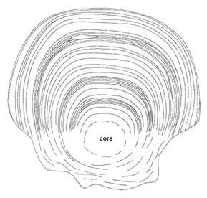

Locomotion – pages 154-155 and handout
- Fish swim to ________________________, ______________________________________, and __________________________. Many cartilaginous and some bony fishes must also swim to ___________________________________ with water to obtain _________________.
- Fishes usually swim with _____________________________________ of the ___________and _____________.
- Sketch an example of a fish. Label the parts used for locomotion and describe their function during movement.

Feeding – pages 155-156
- Describe how filter feeders eat.

- The shape of the mouth of bony fishes tells much about their diets. Use Figure 8.13 to complete the chart.
Illustration/Description | Example | Diet

Behavior – page 161
- Nearly all aspects of the lives of fishes involve complex behavior to adapt to __________ and _______________, to find __________________ and ________________, and ____________________________.
Behavior – Territoriality – page 161
- Define territories and describe what they are used for.

- Fishes use a variety of aggressive behaviors because actual fighting is rare.
  - Bluffing - _____________________________________________________________________________
  - Sound production - _____________________________________________________________________
_____________________________________________________________________________________
Behavior – Schooling – pages 161 – 162
- Many fishes from well-defined groups, or _______________________. Some school throughout their lives while others are part-time schoolers usually as ________________ or during ________________.
- Why do fishes school?
  - _____________________________________________________________________________________
  - _____________________________________________________________________________________
  - _____________________________________________________________________________________
  - _____________________________________________________________________________________
Behavior – Migration – pages 162 – 164
- Define migration and what is the main reason for it?

- Define the following terms and give an example of each
  - Anadromous – _________________________________________________________________________
_____________________________________________________________________________________
  - Catadromous –________________________________________________________________________
_____________________________________________________________________________________
One-sentence Summary – Review charts and your notes from today and answer the questions in 1 sentence.
- How is a fish’s body shape related to its lifestyle?
- How do fish use coloration?
- What can be used to determine the age of a fish?
- What body parts are used for movement in fish?
- How is mouth shape related to the diet of fish?
- How do fish defend their territories?
- Why do fish school?
- What is the reason for migration?

Topic: Biology of Fishes – External
Grade Level: Marine Biology
Time: 1 Class Period

Objectives:
- SC.912.L.17.6 - Compare and contrast the relationships among organisms, including predation, parasitism, competition, commensalism, and mutualism.

Science goals:
- SWBAT describe how a fish’s body shape is related to its lifestyle.
- SWBAT describe different survival strategies of marine fishes.

Materials:
- Newsprint Paper
- Markers
- Textbooks
- Biology of Fishes – External handout
- Anatomy Handouts (class set)

Lesson and Activity:
- Lesson
  - Preparing for Understanding/Background Knowledge
    - Carousel Brainstorming
      - Post the following 8 questions on separate sheets of paper:
        - How is a fish’s body shape related to its lifestyle?
        - How do fish use coloration?
        - What can be used to determine the age of a fish?
        - What body parts are used for movement in fish?
        - How is mouth shape related to the diet of fish?
        - How do fish defend their territories?
        - Why do fish school?
        - What is the reason for migration?
      - Give each lab group a different color marker
      - Have each group go to a paper and answer the question.
      - After a minute, have the groups rotate and answer the next question. Continue rotating until each group has answered all the questions.
  - Integrating Strategies for Understanding
    - Pass out Biology of Fishes – External handout
      - Active Reading – students will need to read their textbooks to complete the handout
  - Checking for Understanding
    - One-sentence Summaries
      - Using the information from the reading and worksheets, students need revisit the questions from the beginning of class and make any corrections.
      - Students then need to write a one-sentence answer to each question.
- Home Learning
  - Finish “One-sentence summaries”

