Step 1: Disassembling A Float-Type Carburetor
Your carburetor contains a small amount of fuel. Prepare a clean bowl to catch dripping fuel and store small parts. During disassembly, inspect the bowl for dirt and debris to determine the condition of your carburetor.

- Remove the fuel bowl from the carburetor body. The fuel bowl may be attached with either a bolt or the high-speed mixture screw.
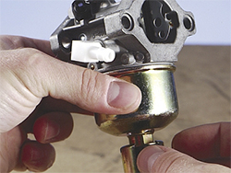

- Push the hinge pin out of the carburetor body with a small pin or pin punch. Take care to tap only the pin to avoid damaging the carburetor body.
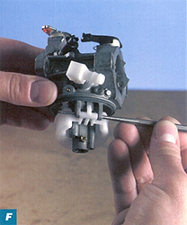
- Remove the float assembly, inlet needle valve and fuel bowl gasket.
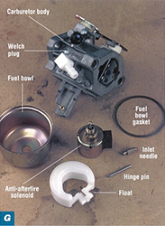

- If your carburetor contains an idle mixture screw, remove it along with the spring.
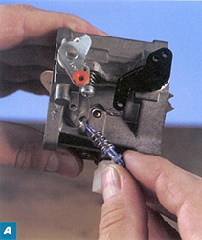

- Rotate the throttle plate to the closed position, remove the throttle plate screws and the throttle plate.
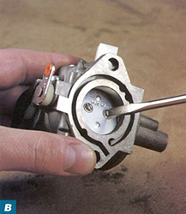

- Remove the throttle plate shaft and foam seal.
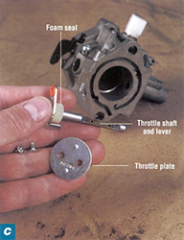

- Then, remove the choke plate and choke shaft and felt or foam washer in the same manner.

- Unscrew the main jet from the side of the carburetor pedestal (if equipped). Then, unscrew the emulsion tube; it may be screwed in tight. A carburetor screwdriver is the best tool for the job. It's designed to fit the slot in the head or the emulsion tube so that you won't damage the threads inside the pedestal of the tube itself as you loosen it.
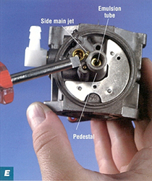

- Remove the emulsion tube. 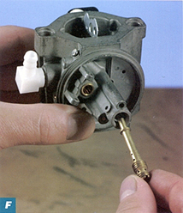

Step 2: Inspecting Air-Fuel Mixture Screws
Brass mixture screws control the air-fuel mixture at high speed and at idle. Over tightening can damage the tip of the screw so that proper adjustment is no longer possible.
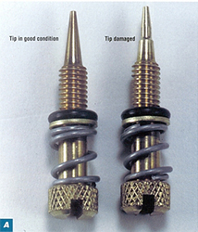
- Remove any non-metal parts and soak mixture screws in carburetor cleaner for 15 minutes.
- Then, inspect them carefully for wear. Replace a mixture screw if the tip is bent or contains a ridge.

Step 3: Parts Identification

Lay the parts on a piece of paper towel. Label the parts listed on the following page as well as the Venturi

Step 4: Reassembling the Small Engine Carburetor
- Assemble the choke by inserting the return spring inside the foam seal and sliding the spring and seal assembly onto the choke shaft. Plastic choke plates have a stop catch at one end of the spring; metal plates have a notch to hold the hook at one end of the spring.
- Insert the choke shaft into the carburetor body and engage the return spring. If the choke lever uses a detent spring to control the choke plate position, guide the spring into the notched slot on the choke lever. Place the choke plate on the shaft with the single notch on the edge toward the fuel inlet. Lift the choke shaft and lever up slightly and turn counterclockwise until the stop on the lever clears the spring anchor. Push the shaft down.
- Insert the choke plate into the choke shaft or attach it with screws so that the dimples face the fuel inlet side of the carburetor. The dimples help hold and align the choke shaft and plate.
- Install the throttle shaft seal with the sealing lip down in the carburetor body until the top of the seal is flush with the top of the carburetor. Turn the shaft until the flat side is facing out. Attach the throttle plate to the shaft with the screws so that the numbers on the throttle plate face the idle mixture screw and the dimples face in.
- Install the inlet needle seat with the groove down, using a bushing driver. Then, install the inlet needle on the float and install the assembly in the carburetor body.
- Insert the hinge pin and center pin. Then, install the rubber gasket on the carburetor and attach the fuel bowl, fiber washer and bowl nut.



